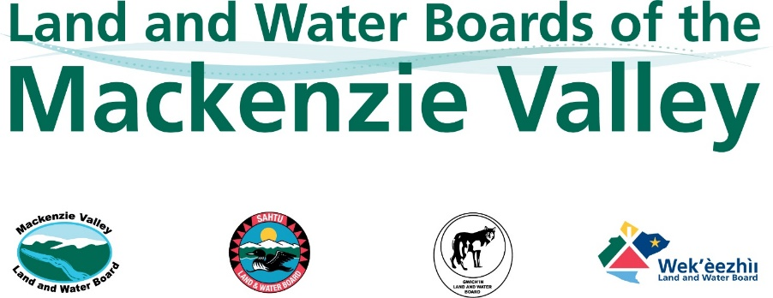

Notice of Intent to File a Claim for Water Compensation
Notifications must be received by the Board no later than the deadline indicated by the Board. This information can be found on the Board’s Online Review System in the Item for Review for the Water Licence Application.

Information about the Application or File

Water Licence Application or file number(s) associated with this Claim:

Information about the Claimant

Claimant’s name (individual or
group/association):
Group or association legal entity:
Community and Province/Territory:
Email: |  | Tel.:

Information about Eligibility
Please identify the category/categories that best describe your relationship with the waters that could potentially be affected by the proposed Licence activities.
Paragraph 72.03(5)(a) of the MVRMA or 26(5)(a) of the Waters Act |  | Existing licensees and applicants with precedence whose water use(s) would be significantly adversely affected
Paragraph 72.03(5)(b) of the MVRMA or 26(5)(b) of the Waters Act | (b)(i) | Existing licence users and applicants with precedence that are not eligible under paragraph 72.03(5)(a) of the MVRMA or 26(5)(a) of the Waters Act
 | (b)(ii) | Domestic users
 | (b)(iii) | In-stream users
 | (b)(iv) | Authorized users
 | (b)(v) | Authorized waste depositors
 | (b)(vi) (MVRMA only) | Persons who use waters or deposit waste (without a licence) under the territorial law
 | (b)(vii) (MVRMA) or  (b)(vi) (Waters Act) | Persons referred to in paragraph 61(d) of the Nunavut Waters and Nunavut Surface Rights Tribunal Act,
 | (b)(viii) (MVRMA) or  (b)(vii) (Waters Act) | Owners of property
 | (b)(ix) (MVRMA) or  (b)(viii) (Waters Act) | Occupiers of property
 | (b)(x) (MVRMA) or  (b)(ix) (Waters Act) | Holders of outfitting concessions, registered trapline holders, and holders of other rights of a similar nature
Subsection 72.05(1) of the MVRMA or 28(2) of the Waters Act |  | Designated Inuit organization
Section 77 of the MVRMA or 33 of the Waters Act |  | Sahtú First Nation (Sahtú Secretariat Inc.)
 |  | Gwich’in First Nation (Gwich’in Tribal Council)
Section 79.1 of the MVRMA |  | Tłįcho First Nation

The Board must be able to confirm eligibility in order to make a determination on a compensation claim. Please explain why you are eligible to make a compensation claim under the category(ies) you selected above.
*Attach any documentation to support eligibility (i.e., water licence, lease, authorization, water licence, lease, authorization, other statement of water use) to this Form.

Please provide information regarding the nature of your use, the duration of your use, and extent of your use of the waters that could potentially be affected by the proposed Licence activities.
*Attach any supporting documentation to this Form (i.e., leases, licences, land titles, etc.).

Information about Potential Impacts
Please describe how the proposed Licence activities could impact the water uses described above. Note that the Board cannot order compensation for past impacts, so your description must focus on the potential impacts that could occur in the future if the Licence is issued.

*Attach any supporting documentation to this Form.

