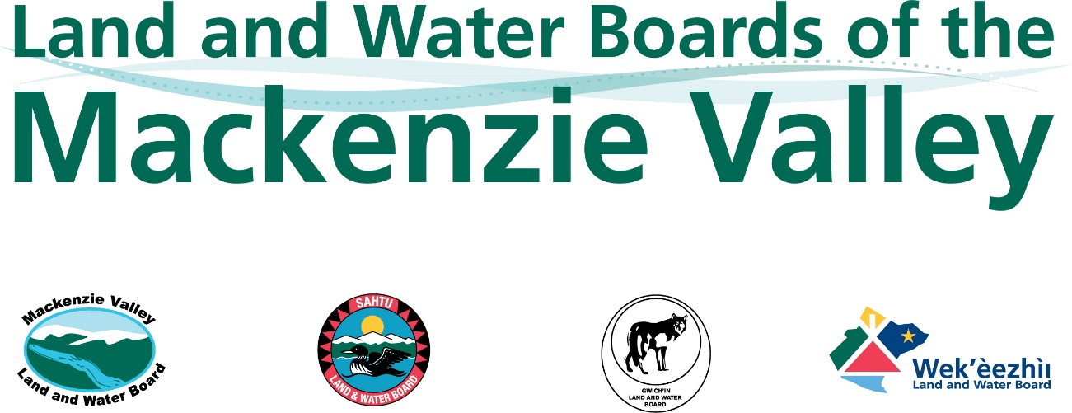

Engagement and Consultation Policy

XX, 2022

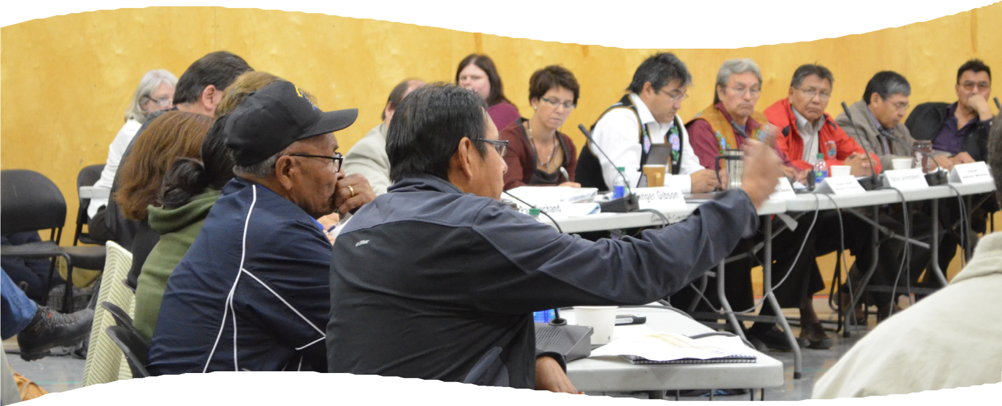

Revisions Table

Reason for Revision | Year
Initial approval and distribution | 2013
Updated with minor editorial revisions based on a legal review of case law (related to consultation) to date and to account for Devolution | 2018
 | 2022

The Mackenzie Valley

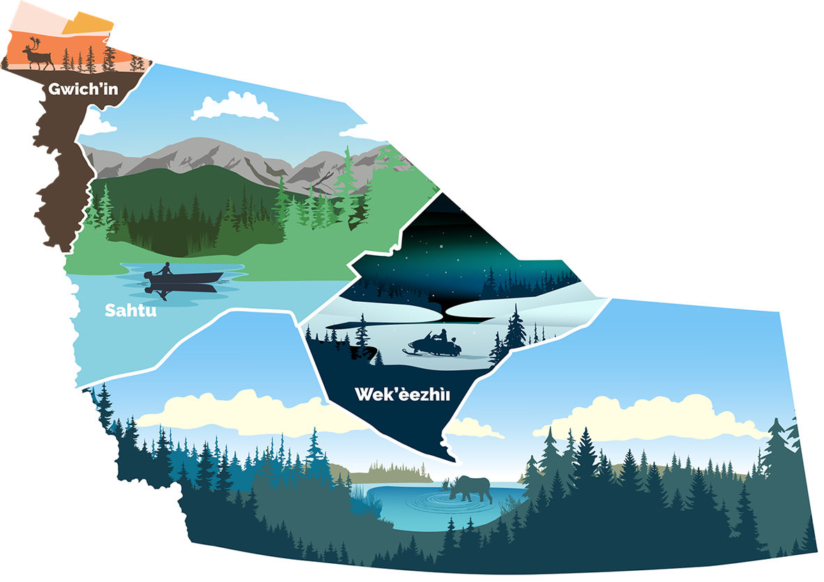

Definitions and Acronyms
TERMS | DEFINITIONS
affected party | a party that is predicted to be affected by a proposed Project, such as an Indigenous Government/Organization, an individual occupying land for traditional purposes, a private landowner, or lease holder (e.g., for a lodge).
applicant | A person who has filed an application with the Board.
application | Any application for or in relation to a land use permit or water licence submitted in accordance with the Mackenzie Valley Resource Management Act (MVRMA), the Waters Act, or their regulations, and includes a request for a Board ruling, a plan approval, or any step required to advance a Board proceeding, but does not include a claim for water compensation.
Boards (LWBs) | Land and Water Boards of the Mackenzie Valley, as established by the Mackenzie Valley Resource Management Act (MVRMA).  - Part 3 of the MVRMA establishes regional land and water boards with the power to regulate the use of land and water, and the deposit of waste, including the issuance of land use permits and water licences, so as to provide for the conservation, development, and utilization of land and water resources in a manner that will ensure the optimum benefit to the residents of the management area and of the Mackenzie Valley and to all Canadians.  - Part 4 of the MVRMA establishes the Mackenzie Valley Land and Water Board (MVLWB).  - Regional Land and Water Boards have been established in the Gwich’in, Sahtu, and Wek’èezhìi management areas and now form Regional Panels of the MVLWB.
Board Statutory Consultation | wherever in the MVRMA reference is made, in relation to any matter, to a power or duty to consult, that power or duty shall be exercised, as set out in section 3 of the MVRMA:  - By providing, to the party to be consulted:  - notice of the matter, in sufficient form and detail to allow the party to prepare its views on the matter;  - a reasonable period for the party to prepare these views;  - an opportunity to present those views to the party having the power or duty to consult;  - By considering, fully and impartially, any views so presented.
engagement | the communication and outreach activities an applicant undertakes with affected parties prior to and during the operation of a Project.
Engagement Record | a summary and log which details the engagement processes and outcomes between the applicant and the affected parties.
Engagement Plan | a forward-looking document that details times and approaches to engagement with the appropriate affected party over the life of the project.
GLWB | Gwich’in Land and Water Board
Crown Consultation | the Crown’s common law duty to consult and accommodate regarding adverse impacts to established or asserted Aboriginal and Treaty Rights protected by section 35 of the Constitution Act, 1982.
Aboriginal and Treaty Rights | Aboriginal rights are practices, traditions, and customs integral to the distinctive culture of the Aboriginal group claiming the right that existed prior to contact with the Europeans (for Métis prior to effective European control). Generally, these rights are fact and site-specific.  Treaty Rights are rights that are defined by the terms of a historic Treaty, rights set out in a modern land claims agreement, or certain aspects of some self-government agreements.
Indigenous Government/Organization | an organization representing the rights and interests of a First Nation (as defined in section 2 of the Mackenzie Valley Resource Management Act), Métis or Inuit organization, , a Tłįcho First Nation, the Tłįcho Government, or the Délı̨nę Got’ine Government.
land use permit (permit) | an authorization required for an activity set out in sections 4 and 5 of the Mackenzie Valley Land Use Regulations, or a land use permit (Type C) required by Tłįchǫ law for use of Tłįchǫ lands, or by a Délı̨nę law for use of Délı̨nę lands, respectively, for which a Type A or B land use permit is not required.

Definitions and Acronyms continued
licensee | A person who holds a water licence issued by a LWB.
Mackenzie Valley | That part of the Northwest Territories bounded on the south by the 60th parallel of latitude, on the west by the Yukon Territory, on the north by the Inuvialuit Settlement Region as defined in the Agreement given effect by the Western Arctic (Inuvialuit) Claims Settlement Act, and on the east by the Nunavut Settlement Area as defined in the Nunavut Land Claims Agreement Act, but not including Wood Buffalo National Park.
MVLWB | Mackenzie Valley Land and Water Board
MVRMA | Mackenzie Valley Resource Management Act S.C. 1998, c.25
NWT | Northwest Territories
permittee | A person who holds a land use permit issued by a LWB.
project | any development (as defined in section 111 of the MVRMA) that requires a land use permit or water licence
SLWB | Sahtu Land and Water Board
water licence (licence) | An authorization required as per Columns III and IV of Schedules D to H of the Waters Regulations (for non-federal areas) and Columns III and IV of Schedules IV to VIII of the Mackenzie Valley Federal Areas Waters Regulations (for federal areas).
WLWB | Wek’èezhìi Land and Water Board

1.0 Introduction

Canada's Northwest Territories (NWT) is located north of the 60th parallel, above Saskatchewan,
Alberta, and eastern British Columbia, between the Yukon and Nunavut. Over 44,000 people live in the NWT, of which, the majority are Indigenous to the region. Much of the population lives in small, remote communities, while approximately 20,000 people live in the capital city, Yellowknife. The territory consists of areas where land claims have been settled and resource and self-government agreements are in place, and areas where negotiations are still underway.

The Mackenzie Valley Resource Management Act (MVRMA), which was influenced by the land claims, provides for an integrated and coordinated system of land and water management in the Mackenzie Valley through the establishment of the Land and Water Boards of the Mackenzie Valley (the LWBs). The LWBs regulate the use of land and water, and the deposit of waste, in the Mackenzie Valley, through the issuance and management of land use permits and water licences. There are four LWBs in the Mackenzie Valley that perform these functions, each in different management areas.

Before issuing a water licence or land use permit, a Board must ensure that the potential impacts of proposed uses of land and water are evaluated and appropriate mitigation and compensation measures are established. The evaluation of potential impacts is guided by Part 5 of the MVRMA, which establishes an environmental impact assessment process for development proposals to “ensure that the concerns of aboriginal people and the general public are taken into account in that process”. The process must have regard to “the importance of conservation to the well-being and way of life of the aboriginal peoples of Canada to whom section 35 of the Constitution Act, 1982 applies and who use an area of the Mackenzie Valley”. The environmental impact assessment process includes preliminary screening, for which the LWBs are the primary screeners, and the LWBs cannot issue a licence, permit, or authorization required to carry out a development unless the requirements of Part 5 of the MVRMA are met.

Given the collaborative system of land and water management in the Mackenzie Valley, and the collective roles in reconciliation, coordinated processes reflecting the shared responsibilities of the parties involved are essential to achieving meaningful involvement of affected parties. Indigenous Governments/Organizations are central parties in this collaboration, and the LWBs endorse the development of plans and protocols for land use and consultation/engagement by Indigenous Governments/Organizations. The LWBs encourage applicants to follow locally-developed protocols and to mutually develop agreed-upon engagement approaches with affected Indigenous Governments/Organizations.
The Crown’s duty to consult and accommodate is also of consequence here,, and in the Mackenzie Valley, the federal and territorial governments have indicated that they rely on the LWBs’ processes to contribute to fulfilling these duties.

The LWBs have developed the Engagement and Consultation Policy (the Policy) to reflect this coordinated system and ensure that their responsibilities for meaningful consultation with all affected parties, including Indigenous Peoples in the Mackenzie Valley, are clearly articulated and met (Figure 1).

Figure 1. Shared responsibility for meaningful involvement of affected parties.

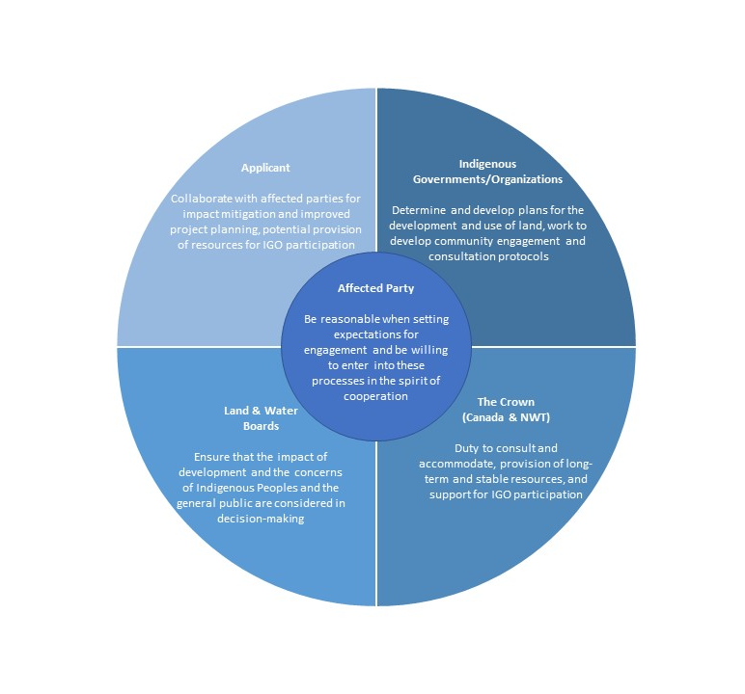

1.1 Purpose and Objectives
The Policy describes the:
- Submission requirements for applicants, permittees, and licensees pertaining to early (pre- submission) and ongoing “life-of-Project” engagement with affected parties; and
- LWB consultation procedures during regulatory proceedings.

This Policy is supported, in part, by the LWBs’ Engagement Guidelines for Applicants and Holders of Water Licences and Land Use Permits (the Guidelines) which include specific requirements and suggested best practices for early engagement and engagement planning with affected parties for the life of a Project. The Policy is also supported by the Board’s Rules for Procedure and other Board policies and guidelines.

1.2 Authority
The LWBs’ roles in consultation are conducted pursuant to the MVRMA, best practices, and in the spirit of reconciliation.

1.3 Application
The Policy applies to all applications and submissions made to a Board by any applicant, permittee, or licensee. The Policy initially came into effect on X, and this version of the Policy came into effect on Y. .

1.4 Guiding Principles
The following principles guide the LWBs’ decisions on any matter related to engagement and consultation with affected parties occurring prior to and throughout their regulatory proceedings. The principles are not listed in order of priority, and they carry equal weight:
- Relationships: Good relationships are the pillar to meaningful engagement and consultation. A strong commitment to fostering dialogue, mutual understanding, and collaboration is required. Building good relationships involves mutual respect, openness, transparency, and a willingness to adapt to what is heard. Engagement should precede and continue during planning.
- Shared responsibility: Coordinated processes, which reflect the responsibilities of the applicant, the Government of Canada, the Government of the NWT, Indigenous Governments/Organizations, and the LWBs to enable meaningful involvement of affected parties, are essential in our co-management system.
- Accessibility: All information relevant to an application or submission is made available in a timely and understandable manner and considers the particular culture(s), language(s), and traditions of the affected parties. The LWBs will make best efforts to ensure the LWB’s processes and requirements support parties in a meaningful way and accommodates their individual needs.
- Inclusiveness: Those potentially affected, including youth, Elders, and women, should be given the opportunity to be heard and involved. It is important to understand the local context and recognize that capacity challenges may exist.
- Reasonableness: Applicants, affected parties, the LWBs, and the Crown must be reasonable when setting expectations for engagement and consultation processes and be willing to enter into these processes in the spirit of cooperation. This includes the provision of reasonable resources, where appropriate, for carrying out and participating in applicant engagement and LWB consultation processes; and consideration of other factors which may affect capacity (e.g. other ongoing initiatives, community events, traditional harvesting activities, global pandemics, etc.).
- Reflection: Engagement should inform the assessment of impacts, project planning, and adaptive management. Parties should work together to determine whether and how recommendations from affected parties can be incorporated. Applicants, licensees, and permittees should explain how engagement has been reflected in applications and submissions.

The LWBs believe that the benefits to good engagement and consulation are boundless and include having the social licence to operate, access to vital local and Indigenous knowledge, and, most likely, better and more efficient regulatory process outcomes.

2.0 LWBs’ Approach
The LWBs’ engagement and consultation policy is:

- To require applicants to initiate dialogue and engagement planning early with affected parties, particularly affected Indigenous Governments/Organizations, well in advance of an application with the goal of:
- explaining the project;
- identifying concerns and potential environmental impacts (including any potential for impacts to Aboriginal and treaty rights);
- addressing concerns raised
- collaborating on project planning including planning for closure and reclamation, monitoring, and mitigation design; and
- ensuring appropriate levels and types of engagement are carried out over the life of an authorization or Project; and

- To apply consultative approaches throughout regulatory proceedings, which assists affected parties to contribute meaningfully towards the assessment of impacts on the environment and the establishment of appropriate mitigations; informs the LWBs’ decisions in relation to licences and permits; andmeets the LWBs’ statutory responsibilities pursuant to the MVRMA.

The following sections outline the LWBs’ policy for engagement requirements and LWB consultation throughout tregulatory proceedings, including LWB process if there is evidence that the Crown’s duty to consult and accommodate has not been met. The policy is described in two parts (sections 2.1 and 2.2).

2.1 Applicant Engagement
It is the LWBs’ expectation that every applicant initiates dialogue early during the ideas/planning stages, and well in advance of making an application to a Board. This is intended to seek and understand the full nature of concerns expressed by affected parties, to consider opportunities to mitigate potential impacts from the project, and to strive toward collaborative project planning and effective consensus-building.
Initiating engagement activities prior to project planning stages also allows for Traditional Knowledge to be incorporated early into a project. Where possible, applicants should follow local Traditional Knowledge policies, protocols, and guidelines, including entering into Traditional Knowledge agreements and following agreed-upon procedures for the use and protection of Traditional Knowledge. Where Traditional Knowledge policies or guidelines do not exist, applicants should consult with communities, Indigenous Governments/Organizations, and Traditional Knowledge-holders to determine acceptable standards for working with Traditional Knowledge-holders and handling the Traditional Knowledge being shared. Like in all early engagement, gathering Traditional Knowledge should be founded on a solid relationship among applicants and affected parties.

An applicant, prior to submitting an application and over the life of the project, is expected to respond to concerns where it can do so and work with affected parties to jointly resolve such issues. The Policy is further based on the expectation that the applicant and the affected parties will make best efforts to consider and to mutually agree upon future engagement efforts that are reasonable in consideration of the scope, scale, and context of the project.

The LWBs’ requirements for engagement are outlined below and more detailed guidance for applicants is provided in the Guidelines.

2.1.1 Submission Requirements
An Engagement Record and an Engagement Plan must be submitted with a new application (see section 2.1.3 for ongoing engagement processes).

Engagement Record
The Engagement Record includes an Engagement Summary and Log for each affected party. The Engagement Summary is a results-based report of engagement with each affected party. It is important that this summary details the outcomes of engagement and documents any unresolved issues. The Engagement Log is a detailed account of all engagement occurrences. The resulting Engagement Record must be comprehensive and provide the Board with evidence of which engagement activities took place prior to an application, a summary of key issues, resulting changes to the proposed Project based on what was heard, and which issues remain unresolved. The Engagement Record must demonstrate early engagement that was done in good faith and that all reasonable measures have been taken to consider and reflect the views of the affected party in the application/submission. For example, a mass email distribution to multiple affected parties notifying them of the contents of a complete application made shortly before the time of application would not, in most cases, be considered reasonable or meaningful engagement.

Engagement Plan
The Engagement Plan is a forward-looking document that details times and approaches to engagement with affected parties over the life of the project. It should reflect the scope, scale, and context of the project (e.g. projects with more potential for impacts will typically require more engagement than others). Elements of the Engagement Plan may need to be specific for each affected party (e.g. some parties may wish to have more/less engagement and at different stages). It is important that the Engagement Plan be completed in collaboration with affected parties.

Applicants should refer to the Guidelines for more details regarding engagement submission
requirements and recommended engagement best practices. The Guidelines also provide suggested approaches to support the submission of engagement documents, including:
- Step-by-step guidance for identifying affected parties;
- Initiation of dialogue and engagement planning; and
- Recommended engagement activities and templates/guides for engagement documentation and planning.
The Guidelines provide suggestions on the minimum recommended levels of engagement and engagement planning based on the type and circumstances of a proposed project. (See Appendix B of the Guidelines.) Examples are also provided to guide applicants working on smaller scale projects that likely require just one permit and which will likely have low or negligible impacts, versus larger projects that will require multiple permits and licences over a longer period of time and could have the potential for higher level impacts.

2.1.2 Assessment of Applicant Engagement
Upon receipt of an application or submission, the LWBs will assess the Engagement Record and the Engagement Plan to determine whether they are complete. The LWBs encourage that both the Record and the Plan are reviewed and signed by the appropriate affected party for verification prior to submission. Signed submissions will normally be considered complete and increase the likelihood of a more straightforward process. If Engagement Record and Engagement Plan submissions are not signed, the LWB will conduct a review against the guiding principles (see section 1.4) to assess:
- Whether the appropriate parties were engaged; and
- The timing of the Engagement activities to ensure sufficient time was provided for the affected parties to fully consider the application and provide their views to the applicant.
At the final decision stage, in addition to considering the two criteria above, the LWB will also assess:
- The achieved results of applicant engagement: any issues that were raised and how those were addressed or if they remain unresolved.

The LWBs will consider requests from applicants for exemptions from engagement requirements and requests from other parties for additional engagement.

The LWBs have the discretion to make such determinations on a case-by-case basis. The LWBs will maintain discretion to address applicant engagement with affected parties throughout the life of a project (for example, by placing conditions in permits or licences that address ongoing engagement).

2.1.3 Ongoing Engagement Post-Issuance of Permits and Licences

Ongoing engagement processes throughout the life of a project are iterative and allow for continued collaboration and evolving relationships. During the life of the project, permittees/licensees must implement the approved Engagement Plan, collaborate on any required changes to it over time, and conduct early engagement for all additional applications or submissions to the Board.

Figure 2 illustrates applicant engagement requirements before an application is made and during the life of the project.

Figure 2. Applicant engagement requirements before an application is made and during the life of the project.
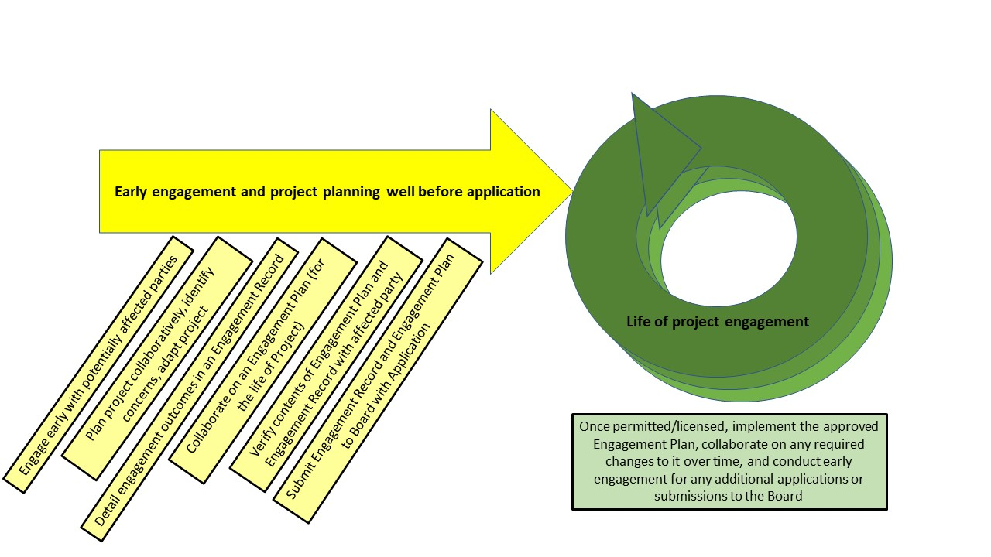

2.2 LWB Consultation

The Boards have statutory consultation obligations under the MVRMA. Section 3 of the MVRMA provides that any power or duty to consult under the MVRMA must be exercised by (i) providing to the party to be consulted detailed notice of the matter, a reasonable period to prepare its views, and an opportunity to present those views to the party with the power or duty to consult, and (ii) considering, fully and impartially, any views presented by the party consulted.

The LWB must consider any Traditional Knowledge and scientific information that is made available to it in its decision-making process. Traditional Knowledge is invaluable to the Board, and must be gathered, used, and considered appropriately. The Boards value the contribution of Traditional Knowledge as evidence in proceedings and will ensure that it is gathered and used in an appropriate way. In addition to following local protocols, policies, and guidelines for gathering Traditional Knowledge, the Boards highlight the importance of using and considering this knowledge in a way that respects the intentions of communities, Indigenous Governments/Organizations, and the individual Traditional Knowledge Holders that provided it.

The following procedural elements form part of the LWBs’ consultation approach:

- Distributing applications to parties for review and comment;
- Conducting preliminary screenings;
- Conducting public hearings;
- Distributing drafts of water licence conditions and land use permit conditions for public review;
- Managing permits and licences after they have been issued; and
- Developing guidelines and policies.

While specific approaches to these consultation requirements may vary among the LWBs, LWB policies for each consultation requirement are consistent and outlined in LWB policies and guidelines which the LWBs rely on in carrying out their proceedings. In particular, the LWBs’ Rules of Procedure set out expectations for proceedings and for parties’ conduct. The LWBs will provide opportunities for meaningful consultation throughout LWB proceedings and will work with individual parties and communities to ensure the proceedings are accessible and meet their individual needs.
In the LWBs’ view, their responsibility to consult is separate from the Crown’s constitutional duty to consult. Although the Government of Canada and the GNWT have indicated that they rely on the Boards’ processes to discharge its duty, the LWBs do not have a constitutional duty to consult. Rather, the LWBs have an obligation to conduct statutory consultation, for the purposes of fulfilling their statutory mandates. Table 1 describes the differences between applicant engagement, LWB consultation, and Crown Consultation. The formal obligations are listed here but the Board notes that meaningful engagement and consultation is, most importantly, best practice.

 | Applicant Engagement | LWB Statutory Consultation | Crown Consultation
Type of Obligation | Board Policy | Statutory (MVRMA) | Common law and constitutional duty
Who is Engaged/Consulted | Anyone potentially affected by the proposed activities | General public and Indigenous Governments/ Organizations | Indigenous Governments/ Organizations
Focus of Discussions | Concerns and potential impacts | Concerns and potential impacts including, but not limited to, Indigenous and/or Treaty rights | Indigenous and/or Treaty rights
Goal | Collaborative project planning to minimize concerns and potential impacts | Ensure that concerns and potential impacts are considered in decision-making | Reconciliation

Table 1: Differences between Applicant Engagement, LWB Consultation, and Crown Consultation

In the case that the LWBs act as a final decision-maker (i.e., where Ministerial approval is not required), the LWB may need to, if necessary, assess the adequacy of consultation by the Crown before making a final decision, taking into account information gathered during applicant engagement and through its consultative processes. Where the LWB is a final decision-maker, the LWB cannot approve a licence or permit if it is not satisfied that the Crown’s duty to consult and accommodate has been met.
Figure 3 demonstrates engagement and consultation in relation to regulatory process steps.

Figure 3. Engagement and consultation in relation to the regulatory process.
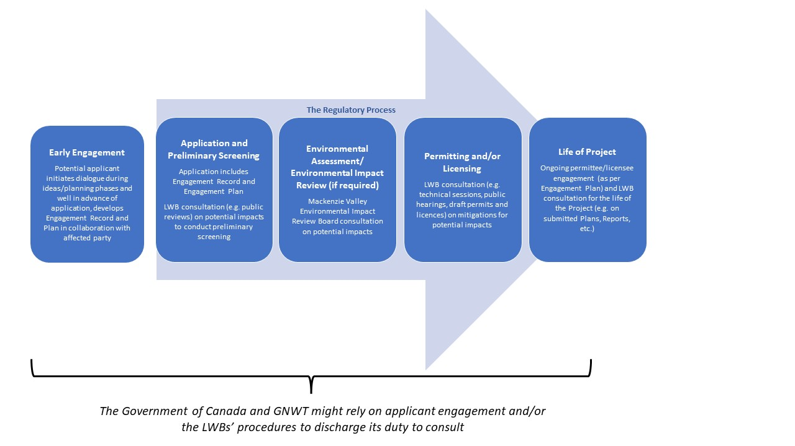

3.0

The Crown is the entity that, at the time of first contact, asserted sovereignty over Indigenous peoples and control over the land and resources then under the control of Indigenous peoples. The Crown existed before the government of Canada, and governments of the territories and provinces were created. The governments of Canada, the territories, and the provinces are subject to the honour of the Crown in their dealings with section 35 rights holders who have rights and title to the land. These governments are made up of three branches, the executive, legislative, and judicial branches. "Crown conduct" requiring consultation generally originates from the executive branch.
The term “Aboriginal” is used in this document only when citing specific legal references; the term “Indigenous” has commonly replaced it as the more recognized term in line with the United Nations Declaration on the Rights of Indigenous Peoples.
The LWBs highly recommend all readers of this Policy become more familiar with the NWT context. A recommended resource is the GNWT Living Well Together resource at https://www.fin.gov.nt.ca/en/services/diversity-and-inclusion/living-well-together
The Gwich’in, Sahtu, and Tłįcho land claim agreements provide for the creation of Land and Water Boards. Part 3 of the MVRMA establishes the regional Land and Water Boards as Regional Panels of the Mackenzie Valley Land and Water Board which carry out responsibilities in the Gwich’in, Sahtu, and Wek’èezhìi management areas. Collectively, they are part of a larger integrated and coordinated system of land and water management in the Mackenzie Valley. Part 4 of the MVRMA creates the Mackenzie Valley Land and Water Board, which has authority to regulate land and water use in areas of the Mackenzie Valley that are not yet subject to settled land claim agreements and to establish, where required, consistent policies for the regulation of land and water in the Mackenzie Valley. For more information, please refer to the NWT Board Forum website at www.nwtboardforum.com
See paragraph 114(c) of the MVRMA
See subsection s115(1) of the MVRMA
See section 62 and subsection 118(1) of the MVRMA
https://www.justice.gc.ca/eng/csj-sjc/principles.pdf
https://www.fin.gov.nt.ca/sites/fin/files/icat/module-2/story_content/external_files/GNWT_rrr_english_brochure.pdf
See examples: https://new.onlinereviewsystem.ca/review/3F5F0DEC-F5D6-EC11-B656-DC9840823EDF, https://reviewboard.ca/upload/project_document/20210205%20-%20EA2021-01%20Initiation%20letters%20FINAL%20-%20KFN.pdf
The LWBs’ guidance documents can be found on the Policies and Guidelines webpage, and the Rules of Procedure webpage, on any of the LWB websites (www.glwb.com/www.mvlwb.com/www.slwb.com/www.wlwb.ca/).
The proposed revisions to the Policy has been influenced by the United Nations Declaration on the Rights of Indigenous Peoples (the Declaration) and Canada’s residential schools: the final report of the Truth and Reconciliation Commission of Canada. As conversations progress around implementation of the Declaration, the Boards will participate in these ongoing discussions and update this Policy as appropriate.
Municipal undertakings and municipal public works activities will generally be considered to be exempt from the typical engagement requirements given their inherent engagement procedures, except for those authorized by type A Water Licences which will be considered on a case-by-case basis and depend on local, formalized engagement protocols.
This does not pertain to information that is protected by law, commercially confidential, or proprietary.
All organizations will have to address capacity for consultation issues within the space of their available human and financial resources. Under the current statutory framework, there is no funding for public participation in regulatory proceedings. It is therefore important for the Government of Canada and the GNWT to ensure that Indigenous Governments/Organizations have capacity at the community level to respond to industry engagement. In specific cases, an applicant may also choose to assist with capacity in addition to the cost of engagement.
Where there is not already an approved Engagement Plan in place, or one that does not require revision. Certain applications made during the life of the project (e.g. storage authorizations, permit extensions, and certain permit amendments depending on the nature) would not require a new Engagement Plan given the Engagement Plan for the initial authorization would apply. Applicants should consider these triggers in their initial Engagement Plan.
Please note that all parties will have the opportunity to provide input regarding the contents of the application, including the Engagement Record and the Engagement Plan, during the LWBs’ proceeding. At the final decision stage, the LWB will consider all evidence, including submissions made during the proceeding.
The Boards have adopted the Mackenzie Valley Environmental Impact Review Board’s Guidelines for Incorporating Traditional Knowledge in Environmental Impact Assessment on an interim basis
The LWBs’ guidance documents can be found on the Policies and Guidelines webpage, and the Rules of Procedure webpage, on any of the LWB websites (www.glwb.com/www.mvlwb.com/www.slwb.com/www.wlwb.ca/).
The Supreme Court confirmed in Clyde River (Hamlet) v Petroleum Geo-Services Inc. [2017 SCC 40] that although the Crown “may rely on steps undertaken by a regulatory agency to fulfil its duty to consult, the Crown always holds ultimate responsibility for ensuring consultation is adequate” (para 22). The Federal Court of Appeal in Tseil-Waututh Nation v Canada (Attorney General) [2018 FCA 153] further explained that “while Parliament may delegate procedural aspects of the duty to consult to a tribunal”, (para 490) “when the Crown relies on a regulatory or environmental assessment process to fulfil the duty to consult, such reliance is not delegation of the Crown’s ultimate responsibility to ensure consultation is adequate. Rather, it is a means by which the Crown can be satisfied that Indigenous concerns have been heard and, where appropriate, accommodated…” (para 493) and “What changes is that the Board’s process serves the additional purpose of contributing to the extent possible to the constitutional imperative not to approve a project if the duty to consult was not satisfied” (para 526).
The formal obligations are listed here but the Board notes that meaningful engagement and consultation is, most importantly, best practice.

