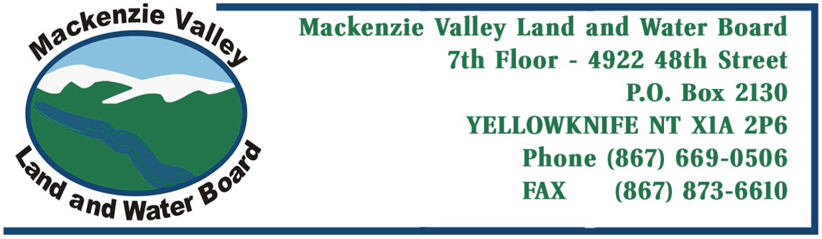

Application for:
New Land Use Permit Amendment to

1. Applicant’s name and mailing address: | Fax number:
 | Telephone number:
2. Head office address:  Field supervisor: Radiotelephone: | Fax number:
 | Telephone number:
3. Other personnel (subcontractor, contractors, company staff etc.)

TOTAL: (Number of persons on site)
4. Eligibility:
(Refer to section 18 of the Mackenzie Valley Land Use Regulations)

a)(i) a)(ii) a)(iii) b)
5. a) Summary of operation (Describe purpose, nature and location of all activities.)

b) Please indicate if a camp is to be set up. (Please provide details on a separate page, if necessary.)

6. Summary of potential environmental and resource impacts (Describe the effects of the proposed land-use operation on land, water, flora & fauna and related socio-economic impacts. Use separate page if necessary.)
7. Proposed restoration plan (please use a separate page if necessary).
8. Other rights, licences or permits related to this permit application (mineral rights, timber permits, water licences, etc.)

Roads: Is this to be a pioneered road? Has the route been laid out or ground truthed?
- Proposed disposal methods.

To complete this section of the application form, a Waste Management Plan for the proposed activities is to be developed in accordance with the Board’s Guidelines for Developing a Waste Management Plan (click here to access) and submitted as an attachment to the application form. A template for this Plan is provided in the Guidelines.

  - Garbage: c) Brush & trees:

  - Sewage (Sanitary & Grey Water): d) Overburden (Organic soils, waste material, etc.):
10. Equipment (includes drills, pumps, etc.) (Please use separate page if necessary.)

Type & number Size Proposed use

11. Fuels | ( ) | Number of containers | Capacity of containers | Location
Diesel
Gasoline
Aviation fuel
Propane
Other
12. Containment fuel spill contingency plans.

A spill contingency plan for the proposed activities is to be developed in accordance with INAC’s Guidelines for Spill Contingency Planning, April 2007 (accessible here). This plan is to be submitted as an attachment to the application form.
13. Methods of fuel transfer (to other tanks, vehicles, etc.)
14. Period of operation (includes time to cover all phases of project work applied for, including restoration)
15. Period of permit (up to five years, with maximum of two years of extension).
16. Location of activities by map co-ordinates (attach maps and sketches) - NAD83
Minimum latitude (degrees, minutes, seconds) |  |  | Maximum latitude (degrees, minutes, seconds)
Minimum longitude (degrees, minutes, seconds) |  |  | Maximum longitude (degrees, minutes, seconds)
Map Sheet no.
17. Applicant
Print name in full

Signature Date
18. Fees Type A - $150.00 ** Type B - $150.00 ** (**Application Fees are Non-Refundable**)

Land use fee:_ hectares @ $50.00/hectare $
Assignment fee $50.00 $ Total application and land use fees $

Please make all cheques payable to “Receiver General for Canada”

